English Grammar and Correct Usage Sample Tests
by Fehl Dungo 287 Comments
We made some English Grammar and Correct Usage tests here including sample questions with answer keys, sentences including correct and incorrect ones. Passing this part of the examination will help you big time in taking other exams as well because correct grammar is so important. We provided tips and helpful lessons you need to pass this English exam.

Important Tips to Ace the English Test for Grammar and Correct Usage
If you know and understand Correct Usage of Verbs, Nouns, Pronouns, Adjectives, Adverbs and grammar, you will surely pass the English exam. It will also help you in answering the other parts like Numerical Reasoning, Logic, Analogy, Reading and Comprehension since they are all in English.
Don’t worry, we will give the blueprint and the best tips here.

Understanding Verbs – their Forms and Usage
Verbs are action words. Their main usage is simple to remember.
Present Tense
Add S when talking about Singular Nouns (he, she, it, everyone, everybody, no one, nobody, either, neither, someone, somebody, anyone, anybody)
Examples:
- Taylor writes her original lyrics.
- Harry dreams of being a wizard.
- She wants to marry you.
- Nobody cares for your Facebook status.
- Everyone knows this is the best reviewer.
Don’t add S when talking about Plural Nouns like – I, You, We, They and other plural nouns
Examples:
- I love her to the moon and back.
- You care for me more than you should.
- We review the CSE pointers to ace the coming exam.
- They watch the concert to see Justin.
- Her children study together every night.
- Many students volunteer for the show.
Past Tense
Add D or ED to regular verbs, used when talking about the past.
Examples:
- Cathy baked a chocolate muffin for me last night.
- The farmers received their first check yesterday.
Irregular verbs, change their spelling:
Examples:
- give – gave – Last Christmas, I gave you my heart.
- write – wrote – I wrote a letter yesterday when I was absent.
Past Participle
Use Has (if singular noun) or Have (if plural noun) following the past participle form of the verb.
Examples:
- She has written the most romantic poem. – since “she” is a singular noun, use HAS + Past participle form of verb
- They have written the funniest story. – since “they” is a plural noun, use HAVE + Past participle form of the verb
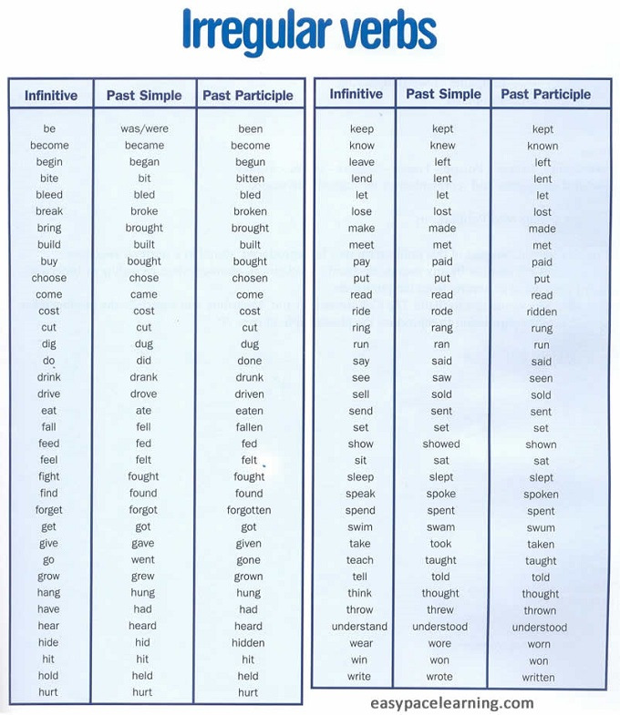

Understanding Pronouns and their Antecedents
Pronouns are words that substitute nouns. Every pronoun has antecedents and they must be near each other.
Sentences examples:
- Every weekend, Sheila practices her piano lessons in her house. (Correct)
- Every weekend, Sheila practices piano lessons in her house. (Incorrect)

Understanding Prefix and Suffix
Prefixes are syllables attached at the beginning of root words.
Suffixesare syllables attached at the end of root words.
Examples and meanings:
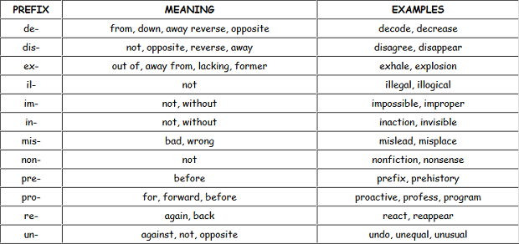
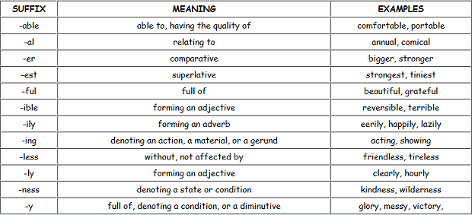

Synonyms and Antonyms
- Synonyms are words with the same meaning.
- Antonymsare words with opposite meaning.

Civil Service Exam Reviewer – English Vocabulary Questions
by Fehl Dungo 93 Comments
The vocabulary part of the Civil Service exam is tough and difficult for many but you can pass the test if you know how to choose the best and right answers. The techniques in getting the right answer is analysing the given sentences – know their consistency and parallelism.
Often, the given choices seem similar and related to each other but there is really one choice that is different and unique among all of them and this is always the best answer that relates to the question.
We are giving free samples of questions here that will help you review well. These vocabulary words are very unfamiliar so you must practice your skills in determining the right answers.
Watch out for conjunctions especially the following: They usually give clues because they connect phrases, clauses and sentences.
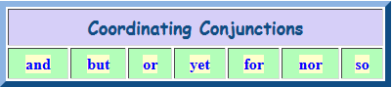
Are you ready to take the test? I hope you are ardent in passing the exam like this kitty below.

Correct Spelling, Idiomatic Expressions with Meaning and Examples
by Fehl Dungo 51 Comments
There are also given questions about choosing the correct spelling of words or selecting the misspelled one. In my honest opinion, spelling is the most challenging exam since words seem to spell correct and you are just choosing from a given set of words. Sometimes there is also an option for “none” or all “are correct.”
This part of the exam is very tricky considering the words may look familiar and common but their spellings are confusing. Often you may think you already know the correct spelling, yet you may be wrong. That’s why we provided the most confusing words with correct spellings here.
We’re giving some of the words usually given for this type of test. Review them well and master them by heart.
committee separate melancholy
occasion license oxymoron
knowledgeable liaison execute
acknowledgment receipt zoologist
meringue anonymous withdrawal
queue yacht vacuum
spontaneous whimsical privilege
malicious accessible nuisance
commission continuous nauseous
eccentric ecstasy lingerie
rhythm fluorescent judgment
accommodate ambiguous hemorrhage
embarrass turquoise equilibrium
maintenance occurrence dilemma
conscience mayonnaise bizarre
etiquette Mediterranean assimilate
bourgeoisie grotesque hygienic
dearth irresistible jeopardy
luscious negligible omniscience
pandemonium quintessential rendezvous

Idiomatic Expressions with Meaning and Examples
Idioms are words and phrases that have figurative meaning, separate from their literal meaning like proverbs and sayings.
Examples:
- Burning the midnight oil – means working or studying late into the night
- Don’t judge the book by its cover – means don’t judge something by its appearance
- Blessing in disguise – something unexpectedly turned out good
- It takes two to Tango – means actions or communications need more than one person.
- Break a leg – means do your very best

Civil Service Exam Reviewer for Analogy and Logic
by Fehl Dungo 63 Comments
Analogy and logic test in the Civil Service Exam is so challenging as well because it requires tough analysis of words and logical meanings between them. The key to finding the right answers to questions in this type of exam is understanding word meanings and analyzing the relationship between words, ideas, phrases in the given set of words.
If you know the famous game on the iphone, ipad and mobile gadgets called 4 pics, 1 word, this type of exam is sort of like that strategy, only easier because in this type of test, you will be given choices, unlike that game, you have no choice at all but to guess the one word or thought that defines the relationship between the given photos.

courtesy of 4 Pics, One Word

Tips in getting the right answer in Analogy and Logic:
- Determine the thought and relationship between the first set of words
- Apply the same thought and relationship among the choices for the next set of words
According to some English Test Reviewers, Analogy questions usually have the following relationship and thoughts:
- Synonym – pretty: beautiful: big: huge
- Antonym – big: small: fast: slow
- Group – wolf: pack: tree: forest
- Cause and effect – rain: flood: quake: sink-hole
- Sequence – study: graduate: plant: harvest
- Classification – blue: color: pants: clothing
- Degree – warm: hot: cold: freezing
- Effort and result – paint: painting: write: letter
- Problem and Solution – tired: sleep: itch: scratch
- Function – keyboard: to type: phone: to call

Reading Comprehension Test, Exercise and Strategies
by Fehl Dungo 315 Comments
One of the challenging exams given from many kinds of test is Reading Comprehension because it is very time consuming. It involves with reading lots of paragraphs, articles, passages, and sections. Do not worry because this reviewer is made to help you pass the exam in one take. Reading Comprehension will be easy if you follow our helpful tips and strategies here. We always provide sample test questions and exercises for this site reviewer.
How to pass the reading comprehension in an exam? The following tips, strategies and exercises are the best reviewer. It will help you practice in finding the right answers in this type of quiz. It really measures how you can comprehend and grasp about the topic in a passage.

Tips in getting the right answers for Reading and Comprehension Exam
Stay calm and don’t panic. As you open the booklet, you’ll definitely see long passages and paragraphs. Do not stress yourself into thinking “wow should I really have to read all of this?” because you really should darling 🙂 Unless you don’t want to pass the test and just waste your chance.
Read with your eyes not with your mouth. Avoid lips movement and whispering because reading with your lips is time consuming besides it will distract everyone. Reading with your eyes is also reading with your mind, it will help you understand what you are reading better.
Do not read word for word. Instead, read group of words or sections at a time for they will help you get the main topic of the paragraph. It will also help you save time and finish the test on time.
Do not read the answers first before the questions and the paragraph, it will only confuse you.
Read fast and understand what you’re reading to get the main idea of the whole passage. Questions are always related about the main idea. What is the main idea? It is simply the main topic and the center of what is being talked about in the article.
Concentrate on the parts of the paragraph where the possible answer can be found.
Take note of the following:
- Main idea – is simply what the story is mainly about
- Climax – is the peak point or highlight of the story
- Plot – is the pattern of events of the story
- Conflict – is the tension and struggle part of the story
- Setting – is where and when the story takes place
- Best or alternative title – is usually being asked too so you must choose the best one that talks about the main idea
Focus on reading and everything will be taken into your mind like a movie playing inside your head. If you focus, you’ll never be disturbed. If you’re disturbed by something in the room, you lose an important key to ace this part of the test.

Paragraph Organization Civil Service Test Examples
by Fehl Dungo 71 Comments
Next to Reading Comprehension, Paragraph Organization in the Civil Service exam is another challenging part. It is not so difficult however, it is also very time consuming. Why? Because it is about finding the correct arrangement of the sentences to form the correct paragraph, article or story. You need to organize sentences – which comes first, then next and so on. Thus, it is called “Paragraph Organization.”
Usually, in this type of test you will be given shuffled sentences and you need to arrange them to form a story or a passage with sense. How would you know, you got the arrangement right? Simple re-read your sequence and ask yourself if it makes sense. No worries darlings, we are giving effective techniques and strategies here because the purpose of this reviewer is for you to pass the exam in one take.

CC BY Andy Rennie Flickr
As usual, we provide paragraph organization test samples and questions below which you can use as reviewer. I will make a PDF version of this book soon. This tutorial and these tips will help you to prepare for your big day at the Testing Center. Relax and you will pass the test.

Tips in Paragraph Organization
Every paragraph, story or an article has a pattern and your goal is to organize the whole pattern to present the main thought chronologically. If it’s hard for you, make an outline of each topic in the sentences.
Watch out for signal words which indicates time or events.
Watch out for the following signal words:
Order or sequence:
- First, second, third, first and foremost, afterwards, then, next, at last, until, finally, lastly
Comparison: Similarities and differences:
- But, however, on the other hand, than, likewise, nonetheless, nevertheless, similarly, oppose to, apparently
Cause and effect:
- Because, hence, thus, therefore, consequently, subsequently

Paragraph Organization Techniques:
- Find the topic sentence. It usually contains the main idea or the main topic
- Next find the supporting sentences that support that topic sentence.
- Find the concluding sentence or the closing sentence. It usually the final thought or conclusion and marks the end of the article, paragraph or story.
So easy right? Now, prepare yourself and answer the following quiz below.

Numerical Reasoning Practice Test – Civil Service Exam
by Fehl Dungo 107 Comments
We are sharing here the best Numerical Reasoning practice test for the Civil Service exam. This page includes the most common questions for this part of the CSE. Just like our other posts, we also include effective tips and techniques to get the best and correct answer to every question. Eventually, the PDF version of this whole online reviewer will be done and the release will be announced in this site. Meanwhile, you can just use this free online reviewer because it contains the complete scope of the Civil Service exam anyway.
Even though there is no calculator allowed, Quantitative Numerical Reasoning is not so difficult in the Civil Service exam especially if the examinee is very good in Math and logic. It involves mainly with the basic Mathematical processes – addition, subtraction, multiplication and division for fractions, ratios, equations, and some problem solving or word problems. There are many series and sequence-questions as well.

Tips to pass the Numerical Reasoning Test in Civil Service Exam
- Relax and just enjoy answering your Math quizzes. If you’re relaxed, you’ll never lose focus and that is so important.
- Know the basics of Math like adding, subtracting, multiplying and dividing fractions, ratios, decimals, and equations. If you know these concepts, you’ll surely get everything. Otherwise, you won’t know what to do. (see our techniques below)
- You can use scratch paper for your computations and solutions. Note that you will also have to pass your scratch papers.
- Love Math because it is easy for someone who loves Math.
- Focus in solving problems. Think, analyze, and solve.
- Pray before the exam. It always helps.
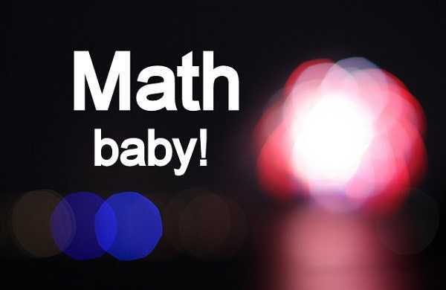

Techniques in Numerical Reasoning Test
For the purpose of reviewing better, I’m going to share here some concepts of Math because like I said, you have to know the basics before you solve everything. I know I have to share these because this is an online reviewer in the first place. Reviewing is practice.
Decimals:
For Addition and Subtraction, it is very simple and easy. Just line up the given numbers though their decimal point. If it has no decimal point, put one or convert one. Put zeros to complement the numbers if needed.
I remember there are many questions about decimals when I took the exam. Lots involve with multiplication and division. Same with fractions, I think I enjoyed that part so much because fractions are my thing.
- Examples:
5.98 + 6 + ¾ = ______
1.25 + 1.5 + 7.875 ______
25 – 8.35 – 1.3 + _______
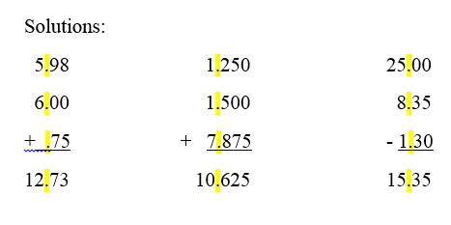
For Multiplication, don’t take it too hard because it is very simply too. Just multiply the numbers and count the decimal places to the right of the given numbers then move in that decimal (count) from the right answer to the left.
- Example: 3.05 x 1.4 =?
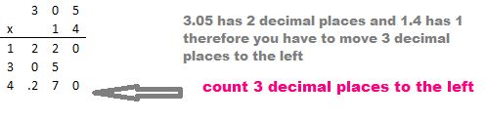
For Division, you have to divide the classic way by making the divisor a whole number. You need to move the decimal place to the right to make it a whole number then do the same way with the dividend. Add zeros to the dividend if necessary. See example below.
- Example: 0.35 ÷ 1.4 (0.35 is the dividend and 1.4 is the divisor here)
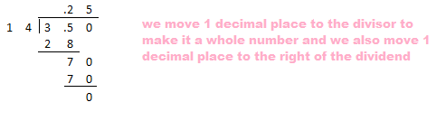
Fractions:
Some of the questions in Math and Quantitative Numerical Reasoning tests involve with fractions because they are also related to decimals, percent, mixed numbers and algebraic expressions. Again, if you master solving fractions, it will be a great edge for you.
Addition and Subtraction of Fractions
In this process, the easiest way is to always simplify the fractions by finding the LCD aka least common denominator, then apply the operation. If the result is improper fraction (numerator is bigger than denominator), simplify it too by giving the mixed number. Watch this helpful video.
http://www.youtube.com/watch?v=GFGlgSfQ-Gk
How to Multiply and Divide Fractions?
To multiply fractions is easier. Just multiply both the numerator then multiply both the denominator. Simplify the product is you must.
- Example: ½ x ¾ = 3/8
To divide fractions, inverse the second fraction then we follow the rules in multiplication. You can also cross-multiply the given fractions.
- Example: How many 1/3’s are there in ½?
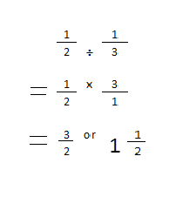
Converting Fractions to Decimals and vice versa
In converting fractions to decimals, just divide the numbers and round them off.
- Examples:
1/3 = .333
5/8 = .625
7/8 = .875
Another way is to find a number to multiply by the denominator to make it 10, 100 or 1000…
- Example:
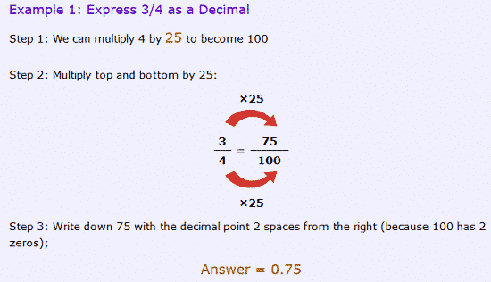
source: Mathisfun.com
Positive and Negative Numbers:
Addition and Subtraction
- Positive + Positive = Positive
- Negative + Negative = Negative
- Positive + Negative = Subtract the two and use the sign of the bigger number
- Positive – Negative = Change the sign of the Subtrahend and follow the rules of Addition
- Negative – Negative = Change the sign of the Subtrahend and follow the rules of Addition
Multiplication and Division:
- Multiplying and dividing numbers with similar sign equals Positive ( + x + = +) and (– x – = + )
- Multiplying and dividing numbers with different signs equals Negative ( + x – = – ) and ( – x + = – )
Number Series and Sequence:
There are also logical sequence and number series in this Math exam. Of course you have to find the next number from the pattern. You will know the right answers by applying the same method you used in a sequence to get the next number or the next.
Examples:
3, 5, 7, 9, 11, 13
2, 4, 8, 16, 32, 64, 128
Problem Solving:
We cannot miss to include this scope here because every Math exam has problem solving. The key to find the correct answers is to analyse the given case well and understand what is being asked. Apply your magical Math logic.

Civil Service Exam Reviewer Clerical Operations
by Fehl Dungo 57 Comments
Clerical Operations or Clerical Reasoning is also covered in the Civil Service Exam in the Philippines especially for the Sub-professional level. As a Career Service Professional, you should know the basic clerical work procedures and office jobs. If you are familiar with the basic job descriptions and responsibilities of a clerk, you will surely enjoy this part of the exam.
You might be wondering how much of the exam has Clerical Operations questions. It’s not much but some questions in English such as filing up alphabetically, arranging chronological orders and office questions are related to Clerical Operations.
There is no need to tackle more about Clerical Reasoning. The best tip is to familiarize yourself in a real-time clerical workplace and you will surely get the correct answers in this quiz.
Again, the objective of this Online Reviewer is to pass the exam in one take. We don’t want you to have information overload. So relax and answer the following questions.

Civil Service Exam – Philippine Constitution, General Information, Current Events
by Fehl Dungo 121 Comments
The Civil Service Exam for Professional and Sub-professional levels also have coverage about Philippine Constitution, Code of Conduct and Ethical Standards for Public officials and Employees based on R.A. 6713; peace and human rights issues and concepts; and environment management and protection, General Information and current events, latest and newly enacted laws and environmental issues.
It is best to know and understand the important parts and sections about the Philippine Constitution and Republic Act 6713. Have enough knowledge about updates and current events happening in the government.
Honestly, this part of the exam is kind of hard to many examinees because lots of us are not very familiar with the political terms, constitution, civil rights, old and new laws. Heck, we must know some from now on.
If you want to go to the complete page of the best Civil Service Exam Reviewer, go in this page : 1taker Civil Service Exam Reviewer

pic: Ronald Tagra Creative Common 2.0

Civil Service Exam 2016 Philippine Constitution, General Information, Current Events
We are sharing here some of the most common questions given in the Civil Service exam for the General information, Philippine Constitution and current events. You’re not taking the BAR Exam so relax and chill out. You don’t wanna tire your brains out darlings. In case you do, here’s the whole Article.

